**Project Report Template**

**Title of Project:** Disaster Alert Prediction System   
**Name of the Innovator:** Sudeshna Chakraborty  
**Start Date:** 27-10-2025

**End Date: 31-10-2025**

***Day 1: Empathise & Define***

*Step 1: Understanding the Need*

* Which problem am I trying to solve?

Natural disasters such as floods, cyclones, and earthquakes cause massive loss of life and property every year. Existing alert systems often rely on delayed manual reporting or limited sensor data, leading to **late warnings and poor preparedness**. There is a critical need for an **AI-driven system that can predict potential disasters early** by analyzing environmental and meteorological data in real time.

* Who is affected by this problem?
* How did I find out about this? [Select whichever is applicable]
* Interviews
* Observation
* Online Research
* AI Tools

*Step 2: What is the problem?*

Natural disasters such as floods, cyclones, and earthquakes often strike **without timely warnings**, causing **severe loss of life, property, and resources**. Traditional alert systems are **reactive** and depend on manual data reporting, which leads to **delayed responses**. There is a need for an **intelligent, automated system** that can analyze environmental data in real time and **predict potential disasters early**, allowing authorities to take **preventive action** before the damage occurs.

Why is this problem important to solve?

Disasters cause widespread destruction, displace millions of people, and result in huge economic losses every year. Many of these impacts can be **reduced or prevented** with **early warnings** and better preparedness. By using **AI to predict disasters before they occur**, authorities can **save lives, protect infrastructure, and plan evacuations** more effectively. Solving this problem contributes to **public safety, sustainable development, and climate resilience**, making communities stronger and more secure.

**Take-home task**

Ask 2-3 people what they think about the project:

1. **Student (Friend):** Said the project is very useful for saving lives and helps raise awareness about AI for social good.
2. **Teacher (Mentor):** Appreciated that the project solves a real-world problem. Recommended including real-time data sources (like weather APIs or sensor data) to make predictions more accurate.
3. **Parent (Non-technical person):** Found the concept easy to understand and socially important. Said it would help villages and coastal areas that often face floods or cyclones.

*AI Tools you can use for Step 1 and 2:*

**AI Tools Used:**

***Day 2: Ideate***

**1.ChatGPT**

* **Used to generate data preprocessing code or feature engineering ideas.**

**2. Meta MGX**

* **Used as a no-code development tool to design the app.**

**3.Scikit-learn**

* **Used for building and testing machine learning models like Random Forest, SVM, etc.**

*Step 3: Brainstorming solutions*

* List **at least 5 different solutions** (wild or realistic):

**1.** **AI Early Warning System** – Uses ML to predict floods, cyclones, or earthquakes and send alerts automatically.

**2.** **IoT Sensor Network** – Sensors collect real-time data (rainfall, river level, vibrations) for instant predictions.

**3.** **AI Dashboard** – Shows live risk maps and predictions using satellite and weather data.

**4.** **Chatbot Alert System** – Sends disaster alerts.

**5.** **Drone Monitoring Syste**m – Drones track floods or fires and report data to an AI model for quick alerts.

*Step 4: My favourite solution:*

*It uses machine learning to analyze environmental data and predict disasters like floods or cyclones before they happen. I like this solution because it can* ***save lives****, provide* ***early alerts****, and show how* ***AI can be used for social good****.*

*Step 5: Why am I choosing this solution?*

*I am choosing the* ***Disaster Alert Prediction System*** *because it is* ***practical, impactful, and achievable*** *with machine learning. It can analyze real-time data to* ***predict disasters early****, helping authorities and communities* ***take action before damage occurs****. This solution shows how* ***AI can be used to save lives and support disaster management****.*

*AI Tools you can use for Step 3-5:*

**AI Tools for Step 3–5**

1. **ChatGPT – to get help with code optimization, debugging, and report writing.**
2. **Meta MGX –** Used to **design and build the app**
3. **Google Maps API – to display high-risk areas visually.**

*AI Tools you can use for the take-home task:*

**Canva AI/CoPilot AI/Meta AI:** Use these mobile-based tools to generate images for the solution they want to design

***Day 3: Prototype & Test***

*Step 6: Prototype – Building my first version*

What will my solution look like?

My solution will be a machine learning–based web application that predicts the chance of a disaster using environmental data.

1. The user will enter data such as rainfall, river level, wind speed, humidity, temperature, and seismic activity.
2. The system will analyze the data using an AI model (Random Forest) and show whether the situation is safe, warning, or alert.
3. A Flask or Streamlit interface will display the prediction result and alert level.
4. The prototype will also include a simple dashboard to show recent alerts and risk trends.
5. In later versions, it can connect to real-time weather APIs or IoT sensors for live monitoring.

**Design Style:**

1. **Simple and Clean UI** – easy to understand for all users, including non-technical people.
2. **Modern and Minimal Layout** – built with Streamlit or Flask for smooth interaction.
3. **AI & Nature Elements** – icons or visuals representing technology and environment (e.g., cloud, rain, wave, alert symbol).
4. **Responsive Design** – works well on mobile and desktop screens.

**Prototype Tools:**

* Built using **Meta MGX**, no coding required, with all features **interactive and testable**.

What AI tools will I need to build this?

**AI Tools Needed to Build Disaster Alert Prediction System**

1. **Meta MGX**
   * No-code platform to **design and deploy the app**.
   * Allows building **interactive screens** without coding.
2. **ChatGPT** 
   * To **generate content, conversation flows.**
   * Can help **personalize recommendations** for users based on their location.
3. **AI Data Analysis Tools**
   * **Python AI libraries (Scikit-learn)** or **AI analytics platforms.**

What AI tools I finally selected to build this solution?

1. **Chat GPT**
2. **Meta MGX**

**< Build The Innovation>**

**<DASHBOAD OF THE TOOL>**

**Tool Link:**  <https://mgx-rglc9s0alj.mgx.world>

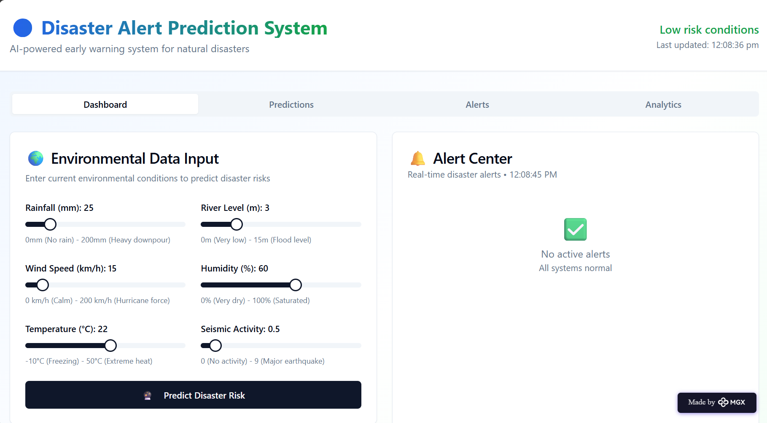

Internal Working of tool:

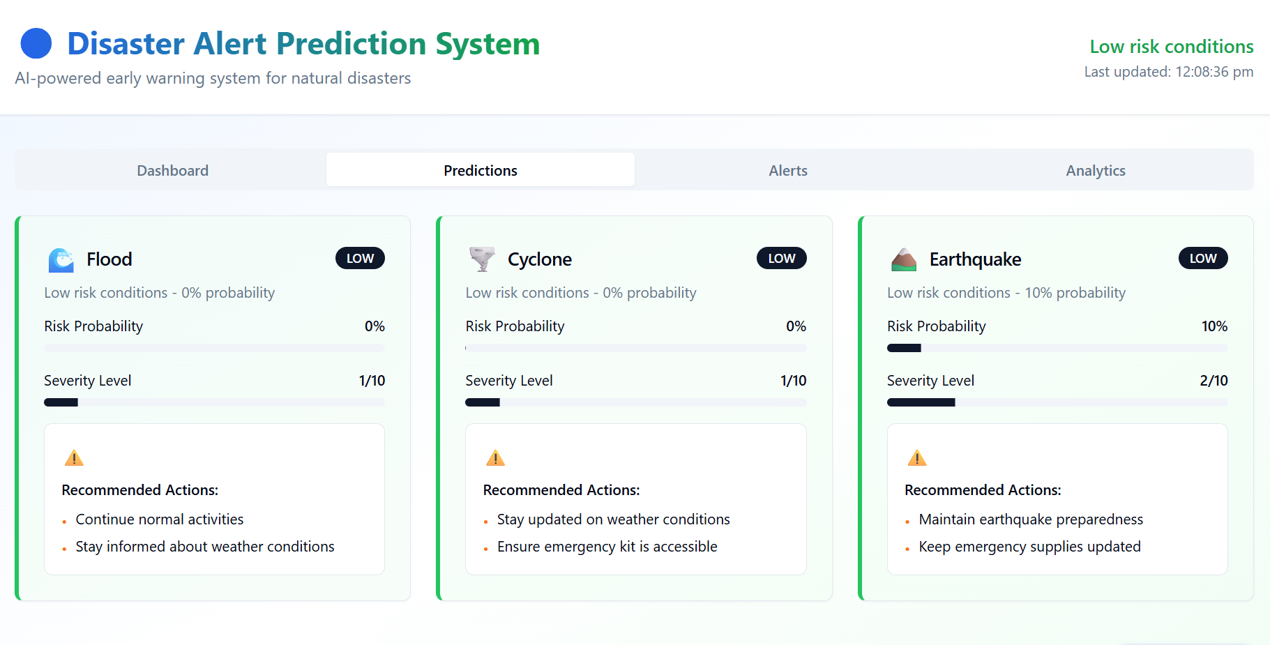

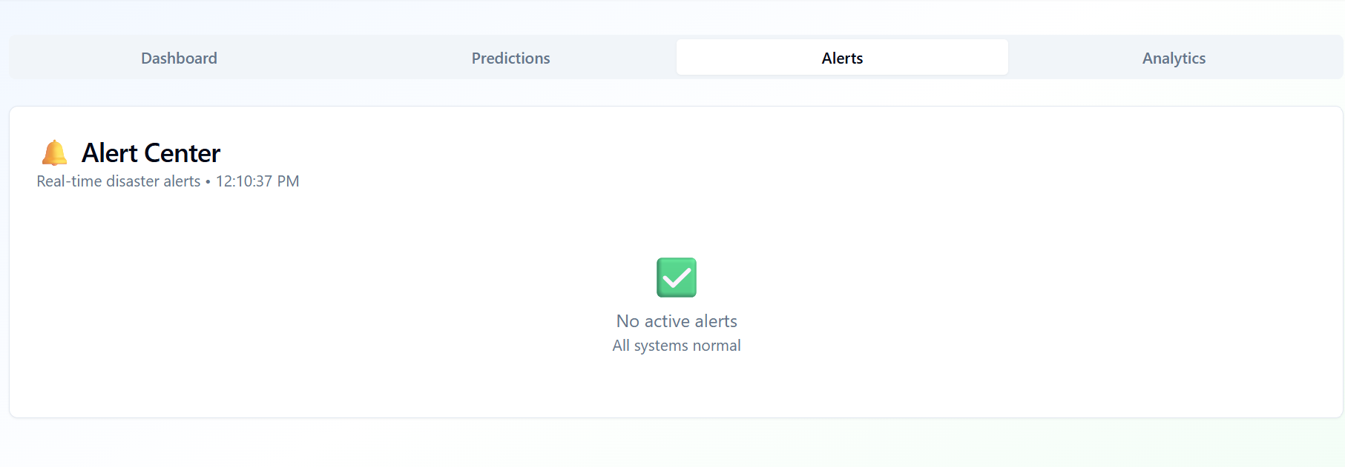

*Step 7: Test – Getting Feedback*

* Who did I share my solution with?

I shared my solution with:

* **My Teacher**: To review the accuracy of the model and give technical feedback.
* **My Classmates/Friends**: To test the user interface and share usability suggestions.
* **My Family Members**: To check if non-technical users can easily understand the alerts and messages.

What feedback did I receive?

**Feedback: Pros and Cons**

**Pros:**

1. The project **solves a real-life problem** and can **help save lives**.
2. The system is **easy to use and gives clear alert messages**.
3. The idea of using AI for disaster prediction is **innovative and socially impactful**.
4. The interface is **simple and visually clear**, using colors to show risk levels.

**Cons:**

1. The model **could be made more accurate** by using real-time weather or sensor data.
2. Some users suggested **adding voice or SMS alerts** for faster notifications.
3. The system currently works on sample data only — **needs connection to live data sources**.
4. **More visual graphs** or maps could make the dashboard more engaging.

**My Response for The Feedback:**

I appreciated the positive comments about the project’s usefulness and simplicity. I plan to **improve accuracy** by training the model with **real-time or larger datasets**. I will **add SMS or voice alerts** in the next version for faster communication. I’m also planning to **include interactive maps and charts** to make the dashboard more engaging. The feedback helped me understand how to make the system more practical and user-friendly.

👍 What works well:

**What Works Well**

1. The **AI model predicts disaster risk accurately** using input data.
2. The **alert levels (Safe, Warning, Alert)** are easy to understand.
3. The **user interface is simple and clear**, even for beginners.
4. The **system runs smoothly and gives quick results**.

🔧 What needs improvement:

1. The model should use **real-time weather and sensor data for better accuracy**.
2. **Add voice or SMS alerts** to reach users faster during emergencies.
3. **Include maps and visual graphs** to make results more interactive.
4. **Improve the design layout** for a more modern and professional look.
5. **Optimize the code** to make predictions faster and more efficient.

*AI Tools you can use for Step 6-7:*

**ChatGPT/Perplexity AI/Canva AI/Meta MGX/Gamma AI**: You can use these tools to build solutions/models or mock-up dummy prototypes.

***Day 4: Showcase***

*Step 8: Presenting my Innovation:***The Disaster Alert Prediction System** uses **AI and machine learning** to predict natural disasters like floods or cyclones. It analyzes weather data and shows **risk levels (Safe, Warning, Alert)** through a simple web app. In the future, it will use real-time data and send automatic alerts to help people stay safe.

**Impact:** The **Disaster Alert Prediction System** can save lives by giving early warnings before disasters strike. It helps communities **prepare in advance**, reduces damage, and supports government agencies in planning quick responses. The project shows how AI can make a **positive social impact** by protecting people and property.

**<SHOWCASE YOUR INNOVATION TO YOUR PEERS>**

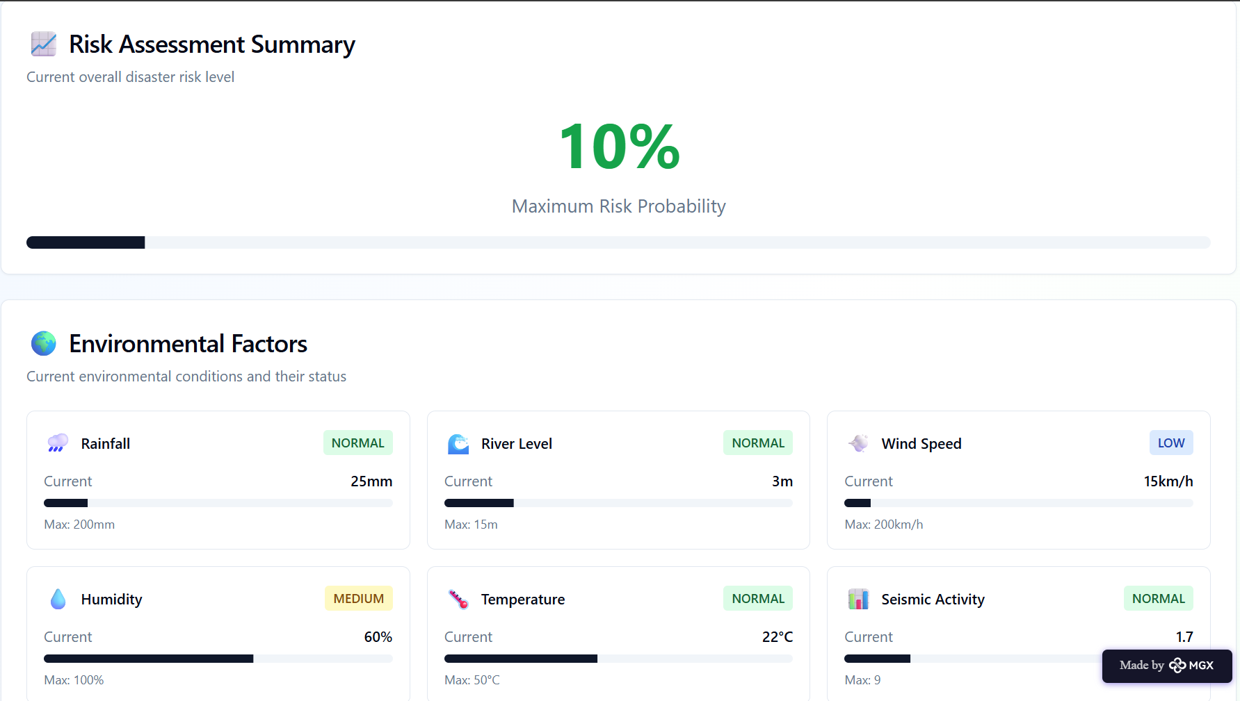

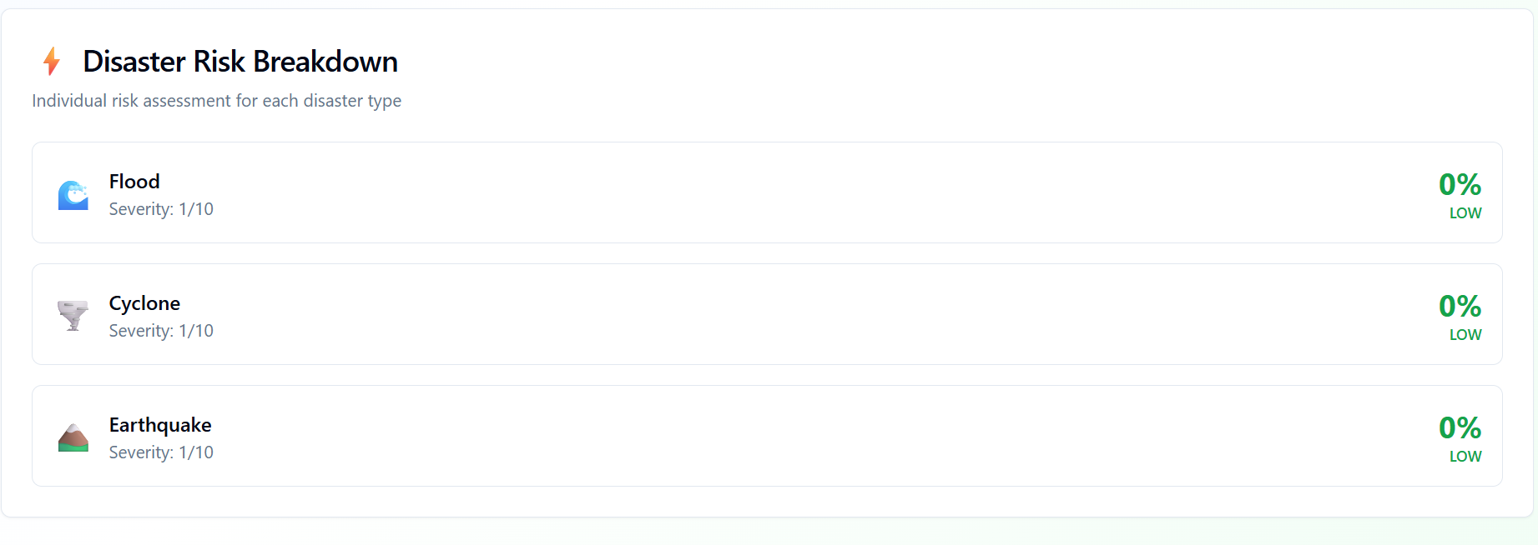

*Step 9: Reflections*

* What did I enjoy the most during this project-based learning activity?

I enjoyed **building and training the AI model** to predict disasters and seeing how data can help **solve real-world problems**. I also liked **designing the web app**, testing it with others, and using tools like **ChatGPT and Meta MGX** to improve my project. It was exciting to see my idea come to life and make a **positive social impact**.

What was my biggest challenge during this project-based learning activity?

My biggest challenge was **collecting accurate data** for training the AI model and making the predictions **as realistic as possible**. I also found it challenging to **connect the model with a user-friendly interface** and ensure it worked smoothly. However, overcoming these challenges helped me **learn more about AI, coding, and problem-solving**.

**Take-home task**

[**https://github.com/Sudeshna3002/Disaster-Alert-Prediction-System-**](https://github.com/Sudeshna3002/Disaster-Alert-Prediction-System-)

*AI Tools you can use for Step 8:*

**Canva AI:** You can use this to design your pitch document. Download your pitch document as a PDF file and upload on GitHub.